8th July 2022

**YOKOHAMA strengthens its senior management team in CEE region**

*Yokohama Europe GmbH has appointed Jarosław Krzempek as General Manager for the Central Eastern Europe organizational structure based in Warsaw.*

Jarosław Krzempek has been named as the new General Manager of Yokohama CEE Sp. z o.o. based in Warsaw, Poland, and will join the company on July 11th.

Jarek brings with him more than 20 years of experience in the tyre industry and has operated most recently as CEO of Prometeon Tyre Group in the East European region for the last 6 years and earlier as CEO Driver Polska in Poland.

Jarek said “I am very pleased to join the YOKOHAMA family. YOKOHAMA is a fantastic company with a long history and great experience. I see considerable potential for further development and promotion of the brand in the whole CEE region”.

Jarek and the rest of the Yokohama CEE management team will work closely to further develop product and customer channels.

This strengthening and restructuring will ensure that YOKOHAMA is best placed to achieve its strategy of continuing to grow sales and market share, particularly of YOKOHAMA´s ADVAN and GEOLANDAR products which already have a significant presence within the high-inch premium segments.

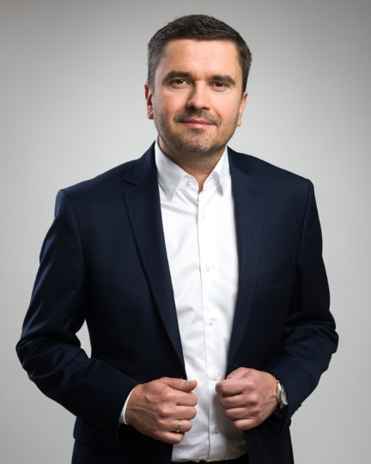

*Jarek Krzempek*