10th July 2024

**YOKOHAMA’s GEOLANDAR X-CV tyres coming factory-equipped on the 2024 Lexus GX 550**

YOKOHAMA announced today that it is supplying its GEOLANDAR X-CV (Pattern No. G057E) tyres as original equipment (OE) to Lexus as an available option on the new luxury on-road SUVs, the GX 550. The tyre sizes are 265/55R20 113V in North America and 265/55R20 109V in Japan. The 2024 GX 550 was launched in North America in April 2024, and general sales in Japan will begin this autumn.

The GEOLANDAR X-CV represents a new standard in highway terrain tyres developed for high-performance crossover SUVs, which have increasingly focused on high-speed performance and manoeuvrability in recent years. Based on the replacement market tyre of the same name, the GEOLANDAR X-CV being delivered to Lexus has been finely tuned to meet the high-performance standards of the new GX 550. In addition to significantly reducing rolling resistance, the tyre provides outstanding steering stability and comfort and is highly reliable even in the harshest environments. The tyre’s sophisticated and stylish side design makes it particularly suitable for use on luxury SUVs, like Lexus GX 550.

Under YOKOHAMA’s three-year (2024–2026) medium-term management plan, Yokohama Transformation 2026 (YX2026), the consumer tyre business aims to maximize the sales ratios of high-value-added tyres. One of the key initiatives under this strategy is promoting the global flagship ADVAN brand tyres and the GEOLANDAR brand tyres for SUVs and pick-up trucks as original equipment for new cars.

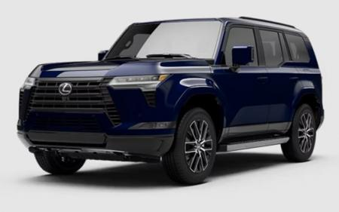

*New GX 550 * The above photo is used with the permission of Lexus.*

*Reprinting or other usage of this image without prior permission from Lexus is strictly prohibited.*

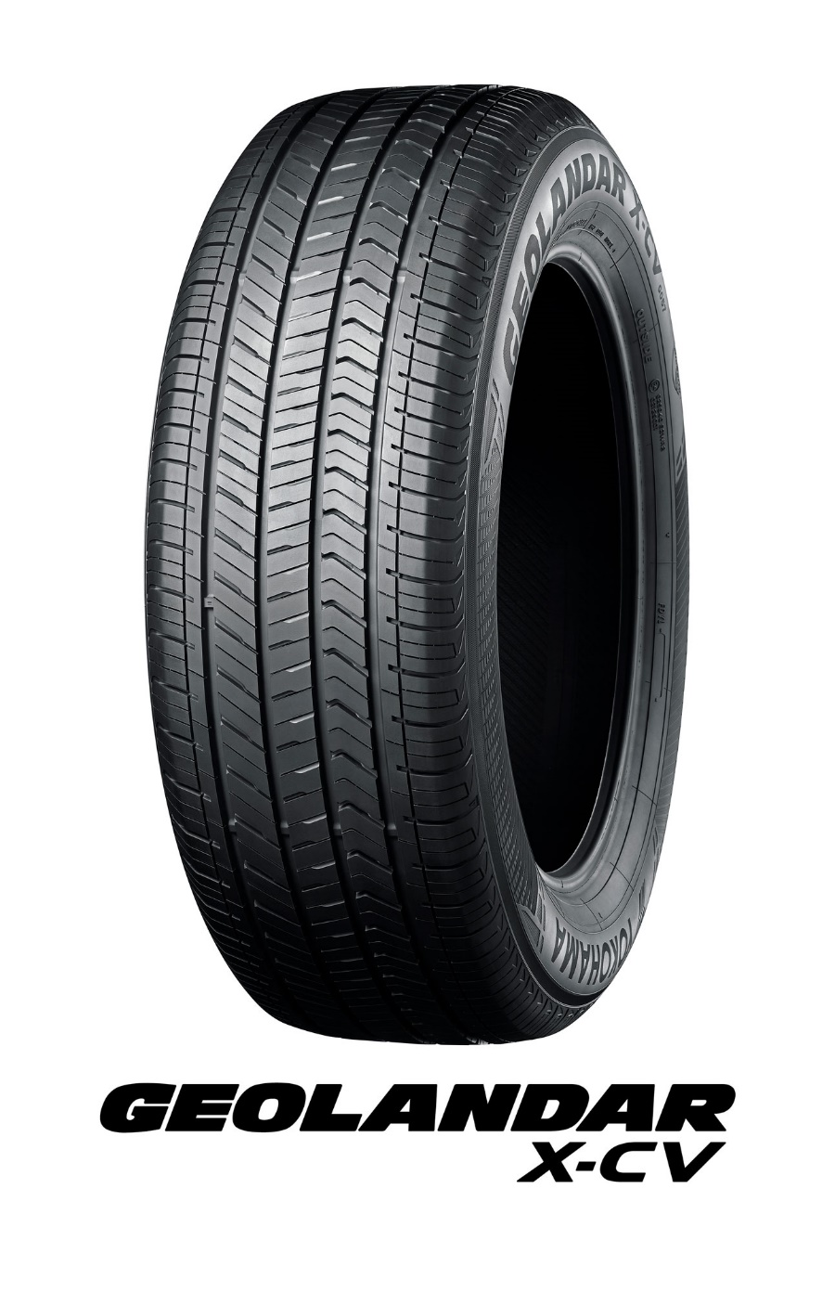

*The tyre size is 265/55R20 109V*