21st June 2024

**YOKOHAMA's GEOLANDAR G94 tyres coming factory-equipped on Mitsubishi’s Pajero Sport**

YOKOHAMA announced today that it has begun supplying its GEOLANDAR G94 tyres as original equipment (OE) to Mitsubishi Motors Corporation for use on the car manufacturer´s Pajero Sport mid-size SUV, which was introduced in Thailand in March 2024. The Pajero Sport is being fitted with 265/60R18 110H size tyres.

*\*Pajero Sport is not available in Japan.*

The newly outfitted GEOLANDAR G94 is an all-terrain SUV tyre equipped with utility performance for running on various road surfaces. The tread rubber and profile are specially tuned to achieve a level of durability that can withstand harsh environments, all while reducing exterior noise and realizing both low rolling resistance and excellent steering stability.

The Pajero Sport embodies the Mitsubishi Motors-ness concept with latest state-of-the-art technology in all aspects - from the new engine 4N16 which provides the ultimate driving performance with the better fuel efficiency and superior controllability in all terrains by the unique technology; Super Select 4WD-II, to the elevated safety features across the board. The new Black – Burgundy interior is enhanced with new sporty premium looks while the refreshed exterior highlights more dynamic, aggressive lines.

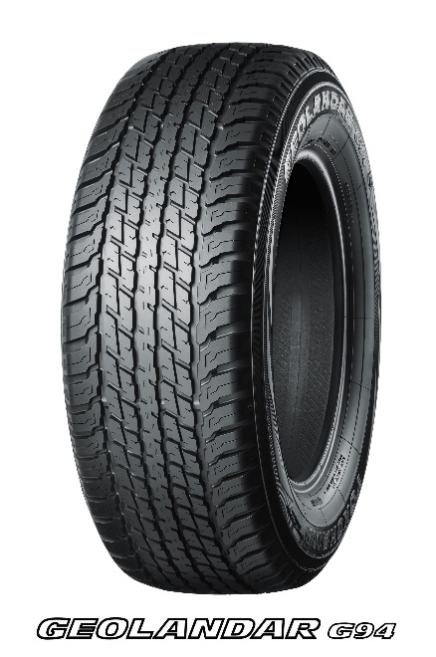Under YOKOHAMA’s three-year (2024–2026) medium-term management plan, Yokohama Transformation 2026 (YX2026), the consumer tyre business aims to maximize the sales ratios of high-value-added tyres. One of the key initiatives under this strategy is promoting the global flagship ADVAN brand tyres and the GEOLANDAR brand tyres for SUVs and pick-up trucks as original equipment for new cars.

*\* The tyre shown in the photo differs in size from those installed on the Pajero Sport.*

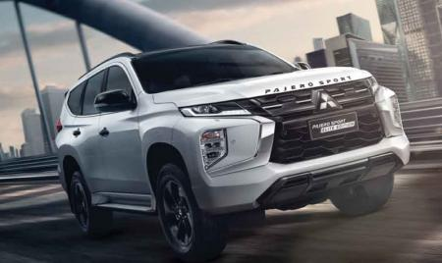

*Pajero Sport *The above photo is used with the permission of Mitsubishi Motors Corporation. Reprint or other usage of this image is strictly prohibited.*