28th June 2024

**YOKOHAMA’s BluEarth-FE AE30 tyres coming factory-equipped on Honda’s new FREED**

YOKOHAMA announced today that it is supplying its BluEarth-FE AE30 tyres as original equipment (OE) to Honda Motor Co., Ltd. for use on the car manufacturer´s new compact minivan, FREED, which will be launched in Japan in June 2024. The FREED is being equipped with 185/65R15 88S size tyres.

The BluEarth-FE AE30 is a fuel-efficient standard tyre in the BluEarth, a YOKOHAMA’s global tyre brand based on the concept of being “environmentally, human, and socially friendly”. It demonstrates excellent fuel-efficiency and a high level of balance between basic performance properties such as quietness, comfortable performance, a comfortable ride, and long life. The BluEarth-FE AE30 being supplied for Honda’s new FREED are made using a compound that contributes to lower road noise and rolling resistance. In addition, the BluEarth-FE AE30’s specially tuned structure enhances the car’s handling stability and ride comfort.

YOKOHAMA is aggressively developing tyres employing its leading-edge BluEarth tyre technology, and many of these tyres are now coming factory-equipped on gasoline-powered vehicles, hybrid cars and EVs such as a wide variety of new car models, including the latest-model sedans, SUVs, sports cars, and compact cars.

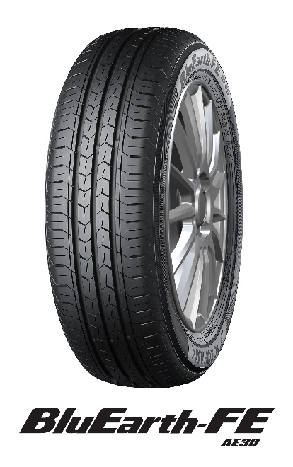

*\* The tyre shown in photo differs in size from those installed on the new FREED. (wheel shown is not standard equipment)*

*Ein Bild, das Fahrzeug, Transport, Landfahrzeug, Rad enthält.
*

*New FREED *The above photo is used with the permission of Honda Motor Co., Ltd. Reprint or other usage of this image without prior permission from Honda Motor Co., Ltd. is strictly prohibited.*