31st May 2024

**YOKOHAMA partners with Baja champion Cameron Steele to supply GEOLANDAR tyres for off-road races in North America**

YOKOHAMA is pleased to announce that it has entered into a new partnership agreement with Cameron Steele, a legend in North America’s off-road racing world. YOKOHAMA will supply Steele with its GEOLANDAR brand tyres for SUVs and pick-up trucks in support of his efforts to win highly popular and challenging off-road races.

Cameron Steele is a highly accomplished driver who has competed in a wide variety of off-road races in North America. He has been a regular participant in world-famous gruelling off-road races, including capturing a class championship in 2018.

YOKOHAMA’s GEOLANDAR tyres have demonstrated superior off-road performance in many races in recent years. In 2023, vehicles equipped with GEOLANDAR tyres captured series championships in the Best In The Desert’s Trick Truck class and the ULTRA4 Racing’s 4900 UTV Pro Mod class. In 2024, vehicles equipped with GEOLANDAR tyres also finished first-place in three classes at the King of the Hammers which is considered the one of the toughest off-road races in the world. YOKOHAMA will be supplying a specially developed off-road race version of its GEOLANDAR M/T G003 mud-terrain tyres that includes sustainable materials. The supplied tyre is environmentally friendly while still providing the surging force needed to win gruelling off-road races.

The consumer tyre strategy in YOKOHAMA’s new three-year (2024–2026) medium-term management plan, Yokohama Transformation 2026 (YX2026), aims to maximize the sales ratios of high-value-added tyres by expanding sales of YOKOHAMA’s global flagship ADVAN brand, the GEOLANDAR brand of tyres for SUVs and pick-up trucks, winter tyres, and 18-inch and larger tyres. YOKOHAMA positions participation in motorsports activities as crucial to its effort to further strengthen the ADVAN and GEOLANDAR brands. YOKOHAMA therefore is again participating in a wide variety of motorsports events around the globe, from top-category to grassroots events.

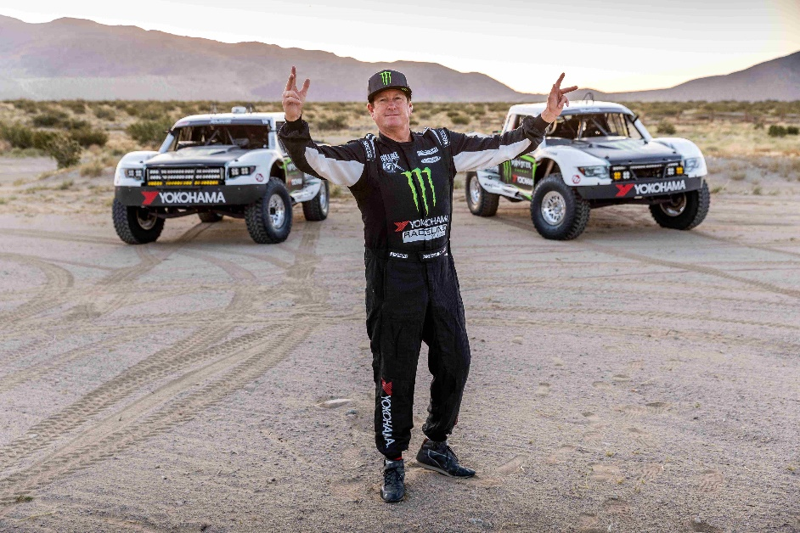

*Cameron Steele*