30th April 2024

**YOKOHAMA introduction of new cell- and cone-type solid fenders creates a more comprehensive fender line-up**

YOKOHAMA announces the addition of two products to its line-up of solid fenders for installation at harbour mooring facilities. The new additions are cell-type and cone-type solid fenders that the company introduces to the market this April. These new high-performance solid fenders supplement YOKOHAMA’s basic model V-type fender, which was launched in July 2023, giving the company a solid fender line-up that meets the diverse needs of a wide-variety of users. Together with its current top-end ABF-P pneumatic fenders, the new additions complement the existing product lineup of giving YOKOHAMA a more comprehensive fender product portfolio that will enable the company to expand its share of the overall onshore fender market.

Fenders are cushioning materials used to protect a vessel’s hull from impact with the quay during harbour moorings and during ship-to-ship operations at sea. Pneumatic fenders use the elasticity of encapsulated air to absorb shock, whereas solid fenders use rubber’s elasticity to absorb shock. YOKOHAMA’s new mid-market cell-type fender has a cylindrical shape that makes the fender highly durable, while the new high-end cone-type fender’s truncated conical shape achieves a higher level of energy absorption upon impact. Both of the new solid fenders are equipped with a buffer plate that absorbs the impact from the vessel’s hull and can be used on quays accepting a wide range of vessels, from small ships to large passenger ships, cargo ships, and tankers. Both new solid fenders have been certified by the Specialists Center of Port and Airport Engineering (SCOPE).

Since its development in 1958 of the world’s first pneumatic fenders for use in the offshore berthing of two vessels, YOKOHAMA has focused on pneumatic fenders used in harsh offshore environments that demand the highest specifications and performance. In 2023, YOKOHAMA leveraged its brand strength and technologies accumulated from its experience with pneumatic fenders to enter the solid fender market, the core fender market. The introduction of two new solid fenders makes YOKOHAMA a comprehensive maker of fenders and further strengthens the company’s revenue base.

YOKOHAMA is currently implementing its Yokohama Transformation 2026 (YX2026), the new medium-term management plan for fiscal years 2024 - 2026. The plan includes a strategy for MB Segment growth driven by concentrating the segment’s resources in its two strongest business domains - hose & couplings and industrial products. As part of this plan, YOKOHAMA aims to achieve steady growth in profits from industrial products by further strengthening the product line-up and maintaining high market shares for fenders and other marine products.

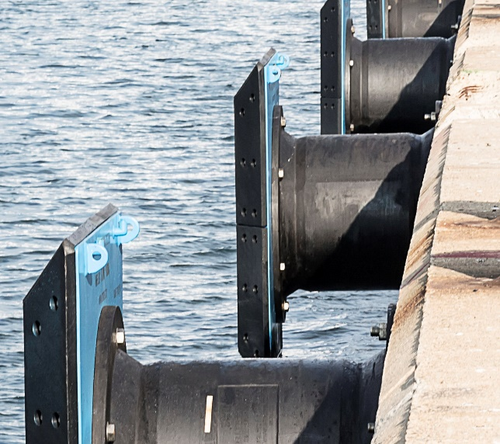 Ein Bild, das Wasser, draußen, See, Dock enthält.

*Cone-type solid fender*

*Cell-type solid fender*