13th May 2024

**Cars running on YOKOHAMA’s global flagship ADVAN brand tyres finish one-two in GT300 class at SUPER GT’s 2nd round**

YOKOHAMA is pleased to announce that cars equipped with its global flagship ADVAN brand tyres finished in first and second place in the GT300 class in Round 2 of the 2024 AUTOBACS SUPER GT Series, Japan’s ultimate touring car racing series. Round 2 was held on May 3 and 4 at the Fuji Speedway in Shizuoka Prefecture. YOKOHAMA is aiming to recapture the GT300 class championship in the SUPER GT Series as part of the ADVAN CHALLENGE, which seeks to maximize sales of ADVAN tyres. This was a great victory on the path to achieving that goal.

This race was the first of the timed races that have been newly introduced from this season. The winner of the three-hour competition was JLOC’s JLOC Lamborghini GT3, whose drivers were Takashi Kogure and Yuya Motojima. After winning the pole position in the qualifying round, which was a first for both drivers in this class, they effectively never gave up that top position from the start of the final race and achieved a great pole-to-win finish. Motojima, who drove a double stint in the race, maintained a high pace from the start and put space between himself and the rival cars. There was no change of driver at the first pit stop and Motojima stayed in first place before handing over to Kogure when there was about one hour remaining, after completing 68 laps. Kogure also continued to drive perfectly and kept all rivals at bay before taking the checkered flag. In addition, second place was taken by KONDO RACING's REALIZE NISSAN MECHANIC CHALLENGE GT-R, driven by Daiki Sasaki and Joao Paulo de Oliveira, so cars with YOKOHAMA Tyres achieved a one-two finish.

The consumer tyre strategy in YOKOHAMA’s new three-year (2024–2026) medium-term management plan, Yokohama Transformation 2026 (YX2026), aims to maximize the sales ratios of high-value-added tyres by expanding sales of YOKOHAMA’s global flagship ADVAN brand, the GEOLANDAR brand of tyres for SUVs and pick-up trucks, winter tyres, and 18-inch and larger tyres. YOKOHAMA positions participation in motorsports activities as crucial to its effort to further strengthen the ADVAN and GEOLANDAR brands. YOKOHAMA therefore is again participating in a wide variety of motorsports events around the globe, from top-category to grassroots events.

Ein Bild, das Sportwagen, Auto, Rennstrecke, Rad enthält.

*JLOC Lamborghini GT3, winner in the GT300 class*

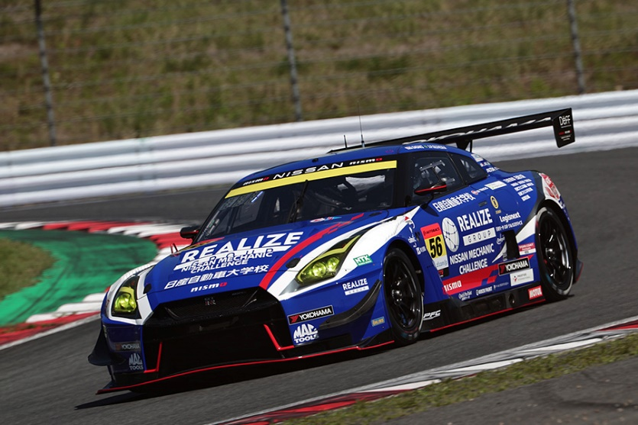

*REALIZE NISSAN MECHANIC CHALLENGE GT-R, second place in the GT300 class*

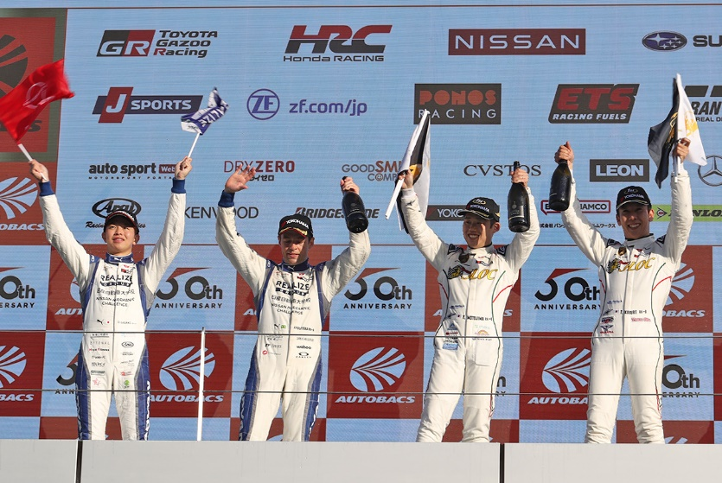

*Winners Yuya Motojima (right center) and Takashi Kogure (right edge), runners-up Joao Paulo de Oliveira (left center) and Daiki Sasaki (left edge)*